The Arts Find Their Place in University Place
For a city of less than nine square miles, you might say University Place is an arts mecca.
One doesn’t have to look far to see public art on full display in this tiny community. It can be found in traffic circles, parks and public plazas. And just in time for the U.S. Open at Chambers Bay, University Place will celebrate the installation of one of its most impressive—and ambitious—public art projects to date.
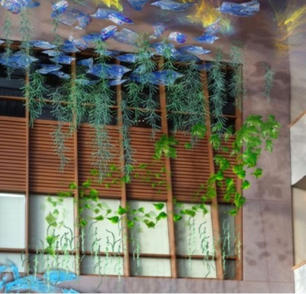
Located in the large sunlit atrium of the City’s Civic Building at 3609 Market Place W., "Between Sea and Sky" is a suspended sculpture composed of individual pieces of hand-blown glass that change their colors, shadows, reflections and patterns with the changing light of each day.
Nationally renowned artist Michele Gutlove created the art, which pays homage to the native flora of the Pacific Northwest. Each piece of sculptural glass in the art is unique in color and form, because as everyone knows, in nature no leaves, trees or birds are exactly the same. A national call for artists drew nine submissions for what the city is calling its “destination art” piece. Those proposals were eventually narrowed down to two. Residents were invited to vote for their favorite during a local festival and overwhelmingly selected Gutlove’s design.
A rendering of Michele Gutlove's "Between Sea & Sky"
To acquire a piece of artwork this significant, the non-profit UP for Arts organization, which is dedicated to supporting the arts in University Place, undertook an aggressive $100,000 fundraising campaign. Two major donors contributed $50,000 to the project and the community then rose to the challenge to meet the $50,000 balance—all in just over a year’s time. “We do not receive any public funding,” says Helen Hein, past president of UP for Arts. “We are just fortunate to have a lot of support from the community.” Given that University Place has a population of just over 31,000 and was able to raise $100,000 in 13 months, some might consider that to be a bit of an understatement.
In addition to its newest undertaking, UP for Arts has been instrumental in bringing other works of public art to the city, all of which, in some way or another, reflect the heritage and values of the community and its residents. With its small size, it doesn’t take long to take an arts tour of University Place, but it is time well spent.
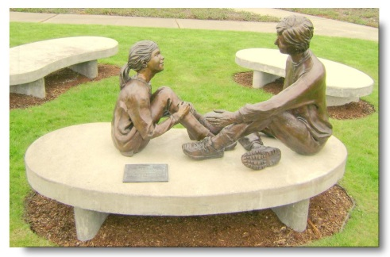
"Sharing," located in Cirque Park at 7250 Cirque Drive W., was created by artist and former U.P. resident John Jewell and was the first piece of art commissioned by UP for Arts.The sculpture reflects the importance of adults passing on wisdom, skills and experience to the next generation. When the piece was being developed, the sculptor was asked to revise his version of "Grandma" to make her a more vibrant woman who would more accurately reflect the spirit of older women in the community.
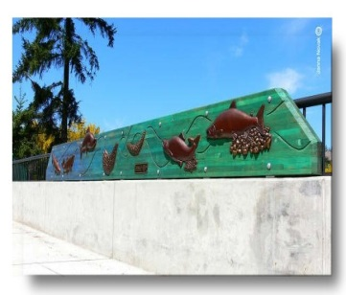
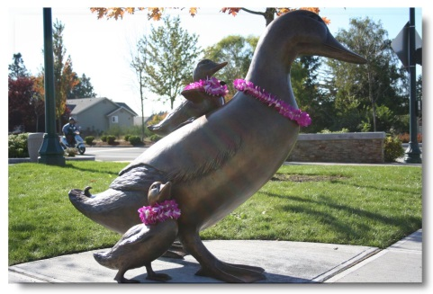
"One Step Ahead" is the work of renowned Northwest sculptor Georgia Gerber. The duck and her ducklings can be found in the public plaza of Market Square at 3609 Market Place W., and were created in honor of Terry Reim, a long-time U.P. resident and commissioner who was instrumental in organizing the community’s annual Duck Daze parade and festival, which celebrate the notoriously wet weather of the region.
"Life Cycle of the Leach Creek Salmon" was created by Lavonne and George Hoivik and depicts salmon returning from the ocean to U.P.’s Leach Creek to spawn. The bronze images are embedded in wood that is attached to the Bridgeport Way bridge near 67th Street. The art complements a public works project that significantly enlarged the culvert under the road so the salmon could complete their life cycle more easily.
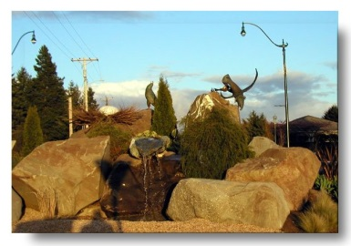
"The Eagles’ Nest" is located in the city’s roundabout at 40th Street and Drexler Drive. It was created by artist Douglas Granum as part of an economic development effort by UP for Arts and the City of University Place. The large boulders, nest and eagles reflect the majesty of the mountains that shadow the city, while the egg represents U.P.'s potential as a community where great things can happen from humble beginnings.
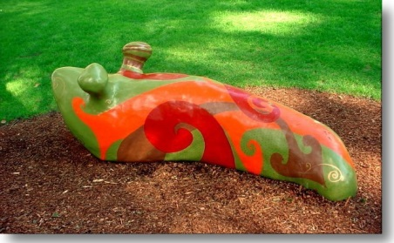
"The Slug" pays colorful and whimsical homage to the creatures that are found in abundance in the Northwest’s wet environs. Artist Christopher Hoppin’s creation is a favorite of U.P. children who visit Homestead Park at 3761 Bridgeport Way W., where they can climb and play on the colorful mollusk whose patterns reflect Maori, Native American and Celtic art.
UP for Arts is also committed to bringing the performing arts to University Place. It is currently in the midst of a $20,000 fundraising campaign to purchase a concert-quality grand piano for the City’s Civic Building atrium. The instrument will be used for public (and private) events, including UP for Arts’ Arts and Concerts series, which has recently paired presentations by glass, mixed media and goldsmithing artists with singers, pianists and jazz performers for Friday night performances and demonstrations.
“We have been able to bring many, many great artists to the atrium,” says Daniel Skelley, owner of Skelley Piano in University Place. Until a piano is purchased, he has been donating the use of his pianos for the atrium concert series. “We recently had the Rimsky-Korsakov String Quartet from St. Petersburg, Russia perform for us. They are world-class musicians.” And yet, people can hear them perform for a mere $10 amid what Skelley calls the atrium’s “amazing” acoustics.
-cont-
Although Debbie Klosowski, a former city council member and one of the founders of UP for Arts, admits people may not realize the true caliber of arts programming they can enjoy, she does believe her fellow citizens appreciate the role arts have in enhancing their community’s quality of life. “The Civic Building is the heart of our downtown, it is our community gathering place,” she says. “We have a lot of very well-traveled people here in University Place and I think they recognize that art, both public and performance, is what makes a city come alive.”

-end-

