
  
Talking UP News from the City of University Place Economic Development Office

December 2024﻿



  ANOTHER NEW BUSINESS OPENING TO CLOSE OUT A BANNER YEAR
  
  Please join us for our final ribbon cutting celebration of 2024 and help us mark another year of tremendous business growth in U.P.
  Five Guys
  3626 Market Place W., Suite 2
  Wednesday, Dec. 18
  11 a.m. to noon
  TRADER JOE'S CELEBRATES 20 YEARS IN UNIVERSITY PLACE
  On Dec. 6, Mayor Javier Figueroa and other members of the U.P. City Council attended the 20th anniversary celebration of Trader Joe’s U.P. store to thank them for their long-standing success and commitment to University Place.
  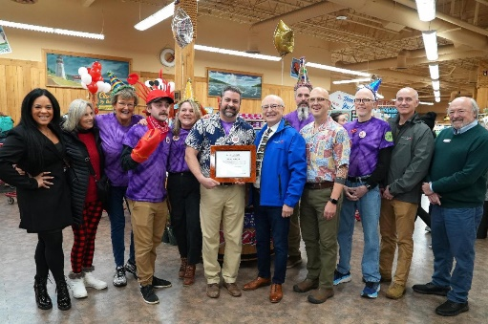
  MAKE FREE SCORE BUSINESS TRAININGS PART OF YOUR 2025 BUSINESS PLAN
  
  Make 2025 your best business year ever by taking it to the next level with free webinar trainings from SCORE Washington. Learn from business veterans how to tackle everything from market research to advertising on the web.
  Let SCORE help you kick off the new year with precise, actionable goals and a roadmap to help your business get there. See the full schedule here.
  CITY HALL HOLIDAY HOURS
  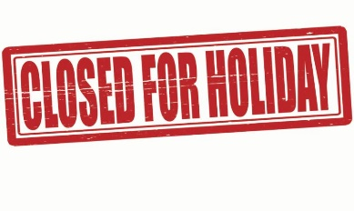
  ﻿Please note that City of University Place offices will close at noon on Tuesday, Dec. 24 and reopen at 9 a.m. on Thursday, Dec. 26.
  Offices will close at 3 p.m. on Tuesday, Dec. 31 and reopen to start the new year fresh at 9 a.m. on Thursday, Jan. 2, 2025.



HOLIDAY WISHES

As we come to the end of another year, we want to thank all of our University Place businesses for your investment in our city and your support of our community.

We extend our best wishes for continued success in 2025.

Kevin Briske, Director of Community and Economic Development
and
Becky Metcalf, Business Outreach Liaison



